**CONTENTS**

1. **PART I:**

**SUBMISSION OF APPLICATION BY COMPUTER OPERATOR**

1. **PART II:**

**TRACKING OF APPLICATION STATUS BY COMPUTER OPERATOR**

1. **PART III:**

**ISSUANCE OF CERTIFICATE BY PRADHAN GRAM PANCHAYAT**

1. **PART IV:**

**REPORTING AND CERTIFICATE DISPATCH BY PRADHAN GRAM PANCHAYAT**

**USER MANUAL**

**FLOWCHART**

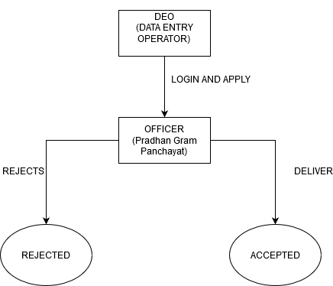

**PART I:**

**SUBMISSION OF APPLICATION: (BY COMPUTER OPERATOR)**

STEP 1:

**At first login to Service plus web portal: (** [http://tathyasathi.bangla.gov.in](http://tathyasathi.bangla.gov.in/))

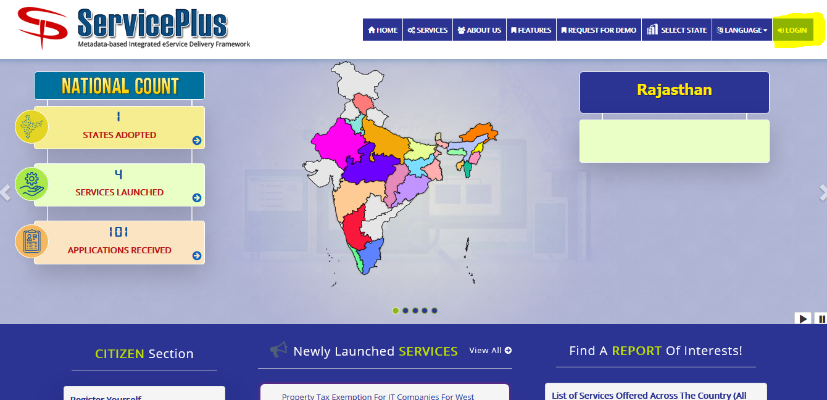

STEP 2:

Login as highlighted with the required credentials such as User ID and Password as shown below with the captcha.

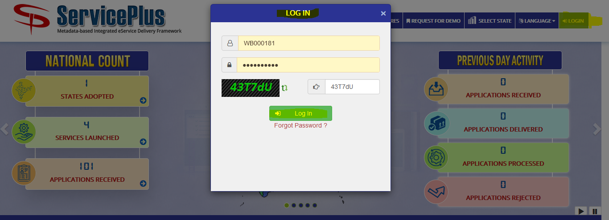

STEP 3:

After Logging in select “**Apply for Services**” from the dashboard and select “**View all available services**” to view your submitted service.

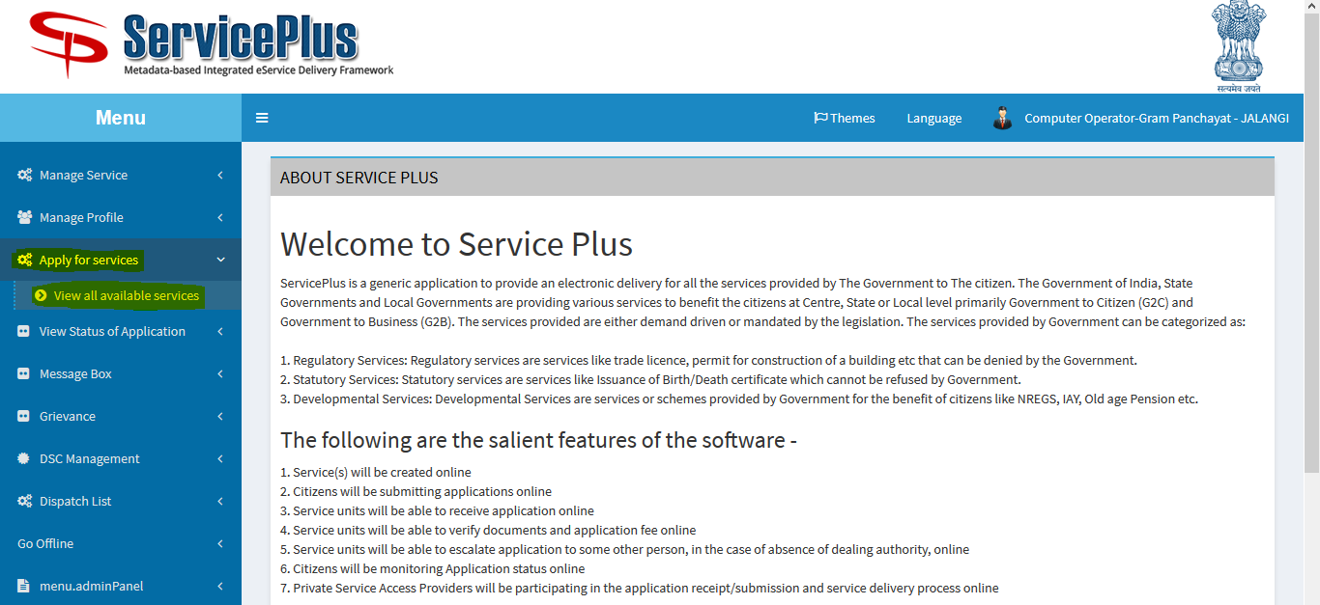

STEP 4:

After selecting “**View all available services**” now select your “**Application for issuance of Janani Suraksha Yojana Certificate - GP**” to check your application.

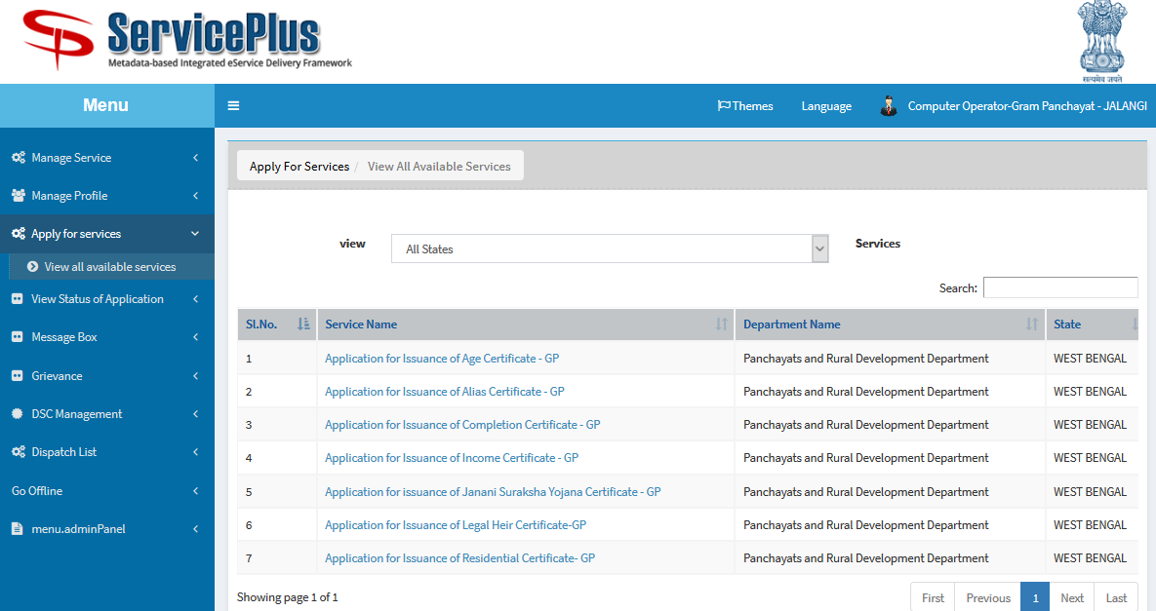

STEP 5:

Now fill in with the valid applicant’s details as required.

After filing the details, give the required captcha and submit the form.

Blank Form:

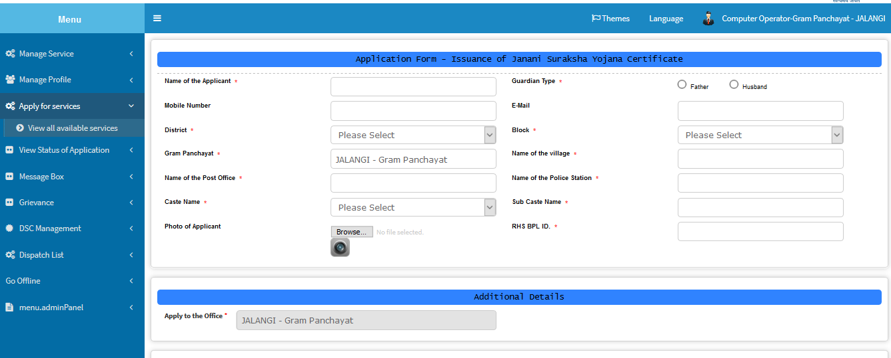

Filled up Sample Form:

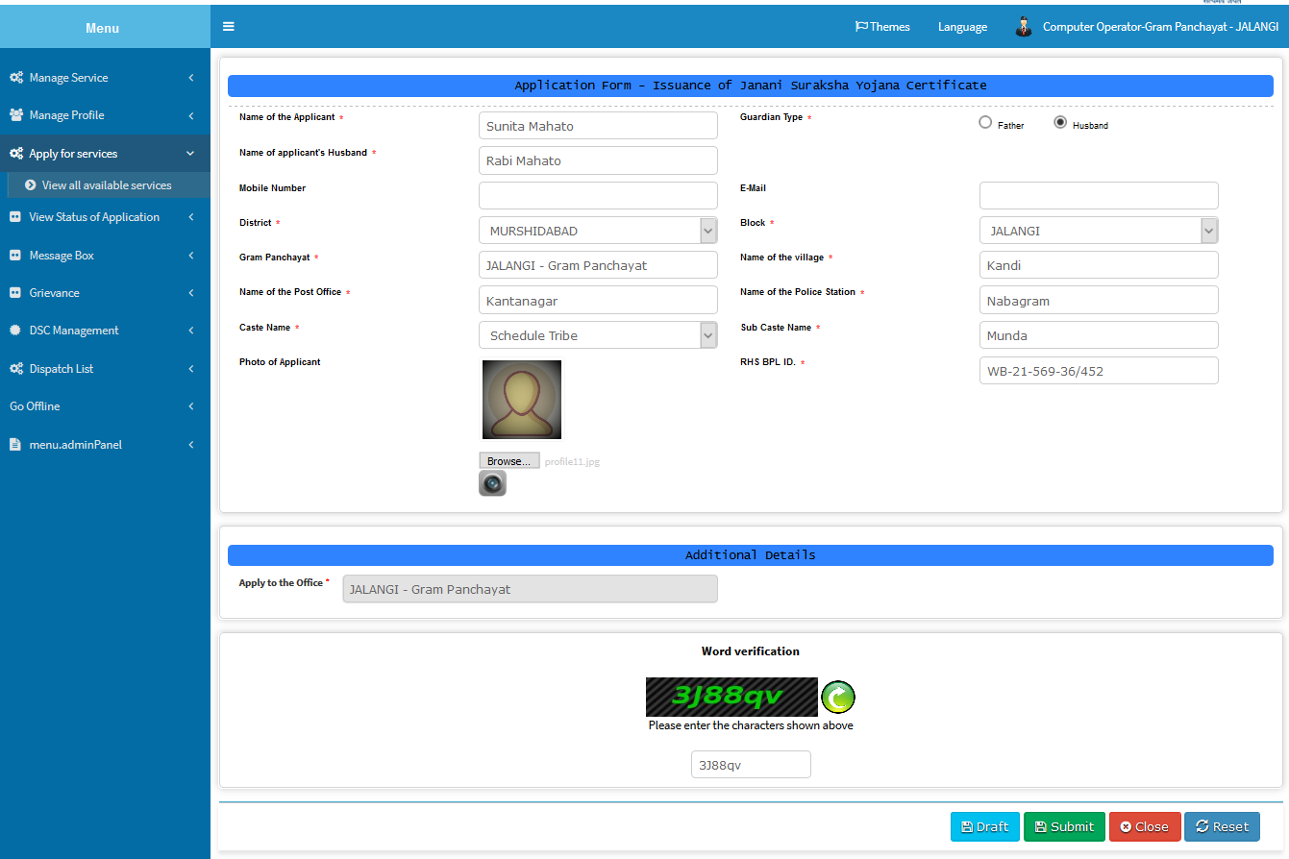

STEP 6:

This is preview after which you can re edit it by clicking “Edit” or submit it by clicking “Submit”.

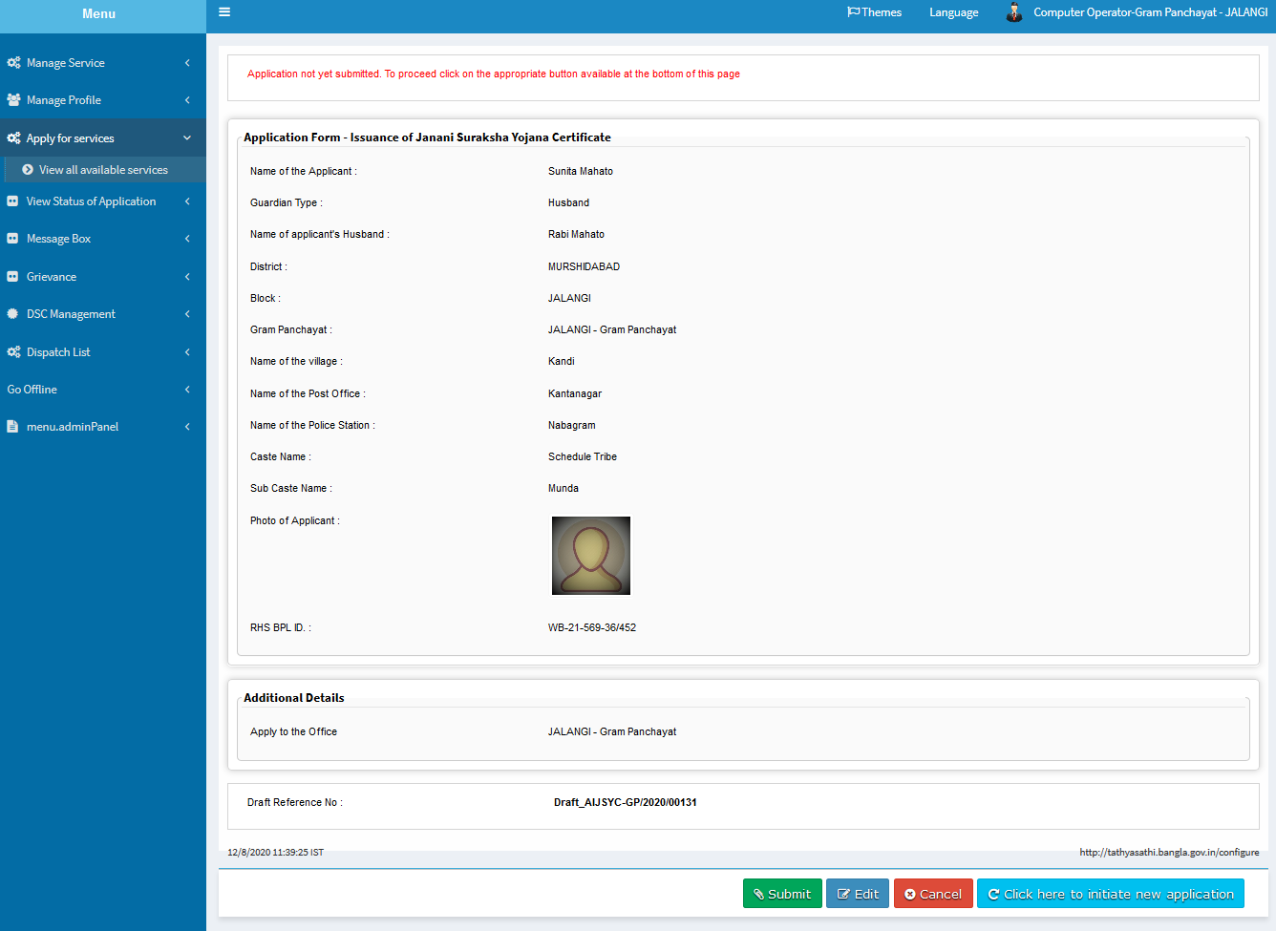

STEP 7:

This is the applicant’s acknowledgement slip with ref-no: AIJSYC-GP/2020/00122 which can be printed or downloaded as pdf respectively.

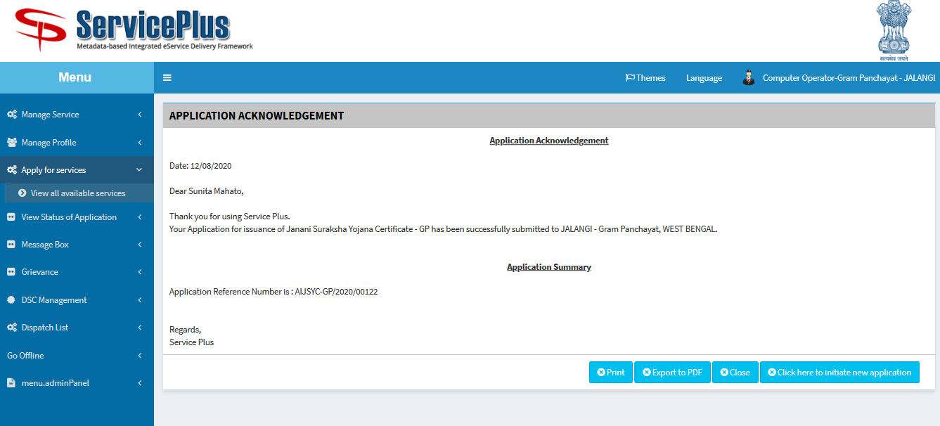

**PART II:**

**TRACKING FOR ISSUANCE OF APPLICATION CERTIFICATE:**

STEP 1:

The Applicant’s application can be tracked by going to “**View Status of Application**” and selecting “**Track application status**” by providing “**App Ref No.”** (Application ref. no:) ********** and selecting “**Get Data**” button.

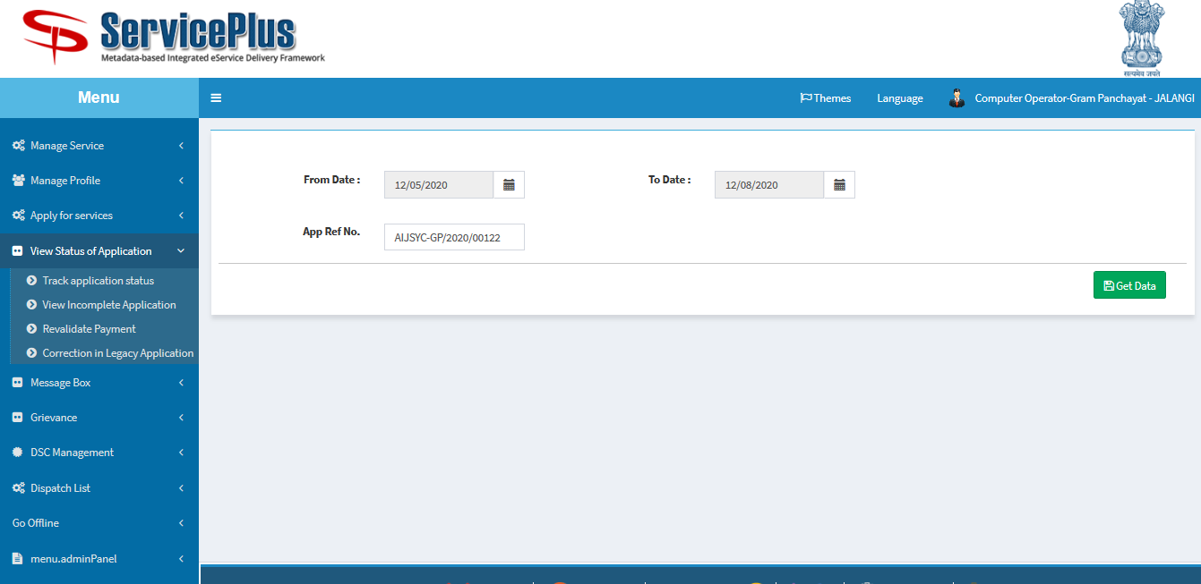

STEP 2:

After getting the list of data select the preferable Service Name which are delivered.

By selecting “**Delivered**” we can get the details of the Janani Suraksha Yojana certificate.

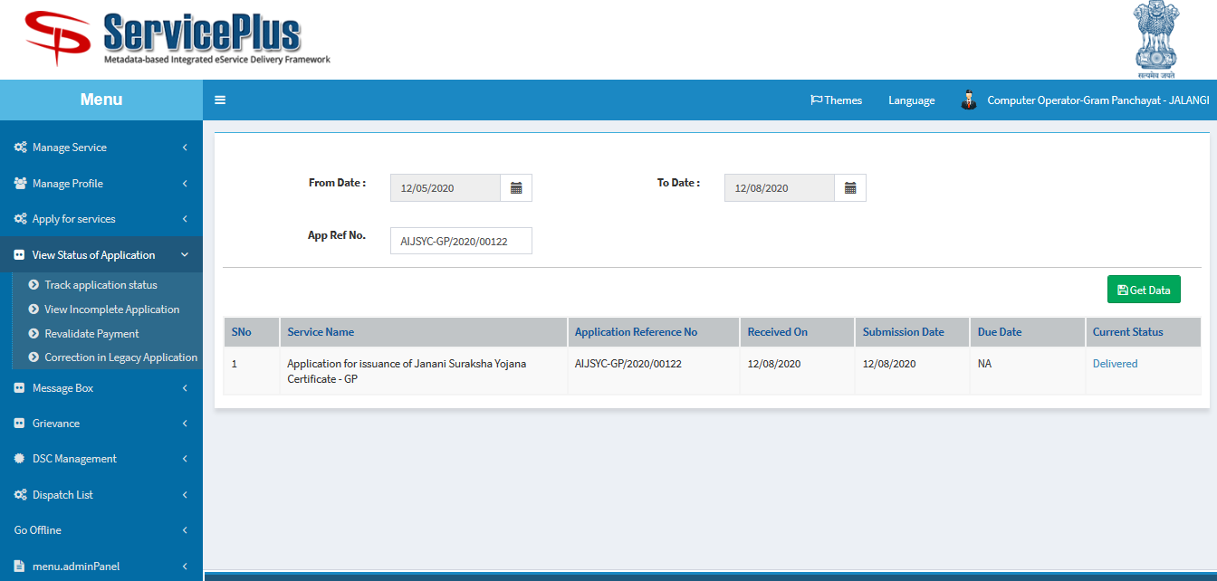

STEP 3:

After selecting delivered a modal pops up with applicant’s all details such as their ‘Janani Suraksha Yojana certificate’ provided, ‘Submitted Application Form’ etc. which can be downloaded for future use.

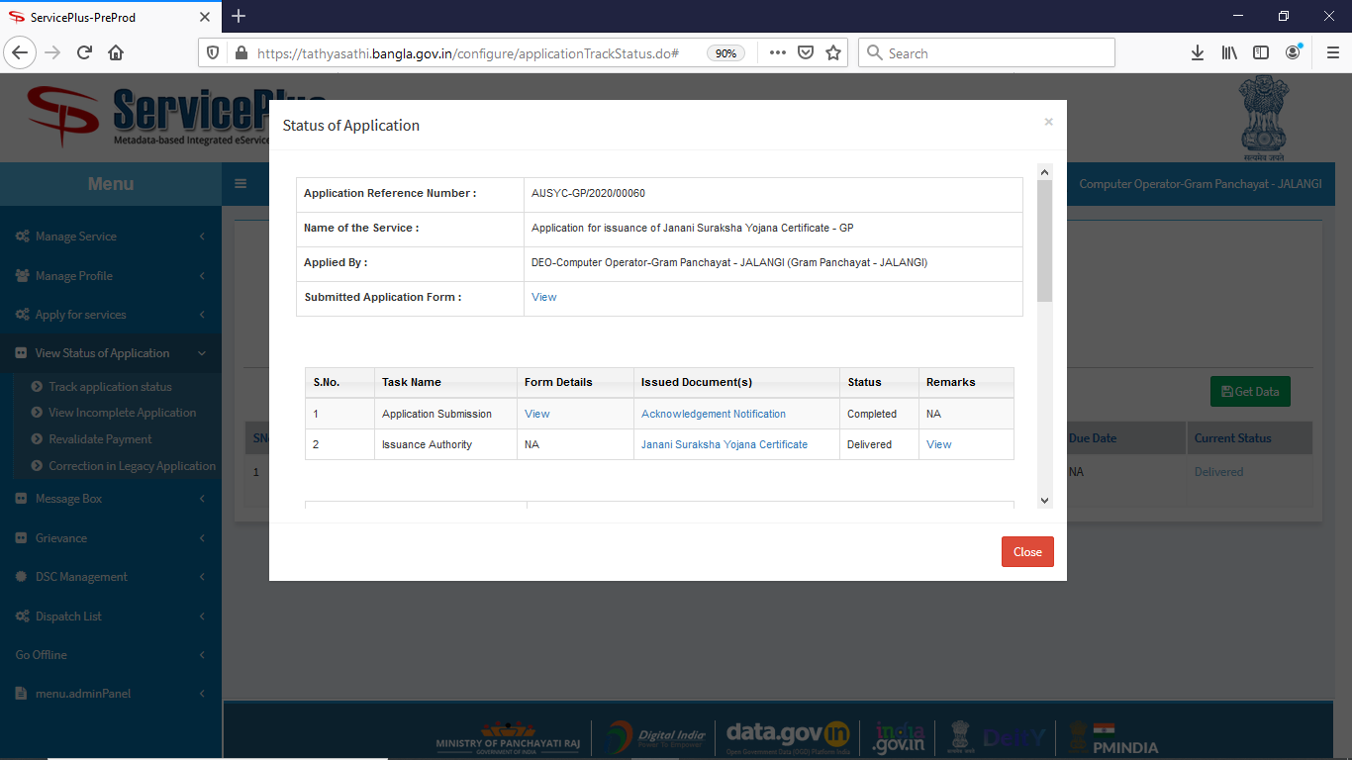

STEP 4:

A Sample of **Janani Suraksha Yojana certificate** has been provided which can be get by selecting the **Janani Suraksha Yojana certificate**.

The QR code and Certificate No. is unique.

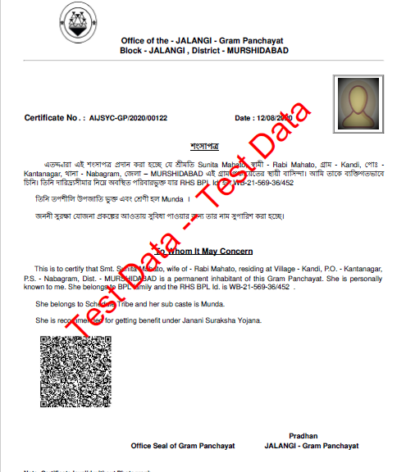

**PART III:**

**ISSUANCE OF JANANI SURAKSHA YOJANA CERTIFICATE: (By PRADHAN GRAM PANCHAYAT)**STEP 1:

**At first login to Service plus web portal: (** [http://tathyasathi.bangla.gov.in](http://tathyasathi.bangla.gov.in/))



STEP 2:

Login as highlighted with the required credentials such as User ID and Password as shown below with the captcha.

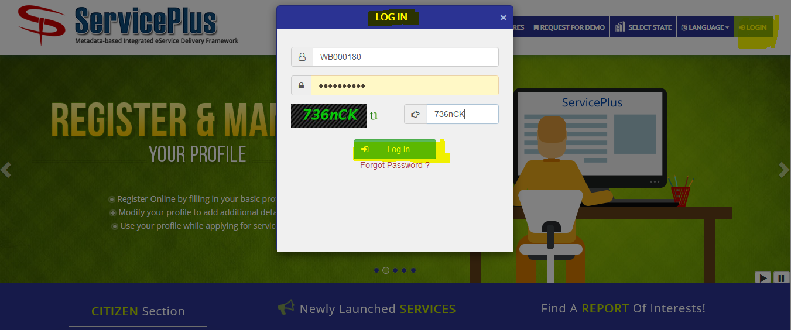

STEP 3:

Here the applicant’s application can be accepted or rejected by going to “**Message Box**” and selecting “**Inbox**”. 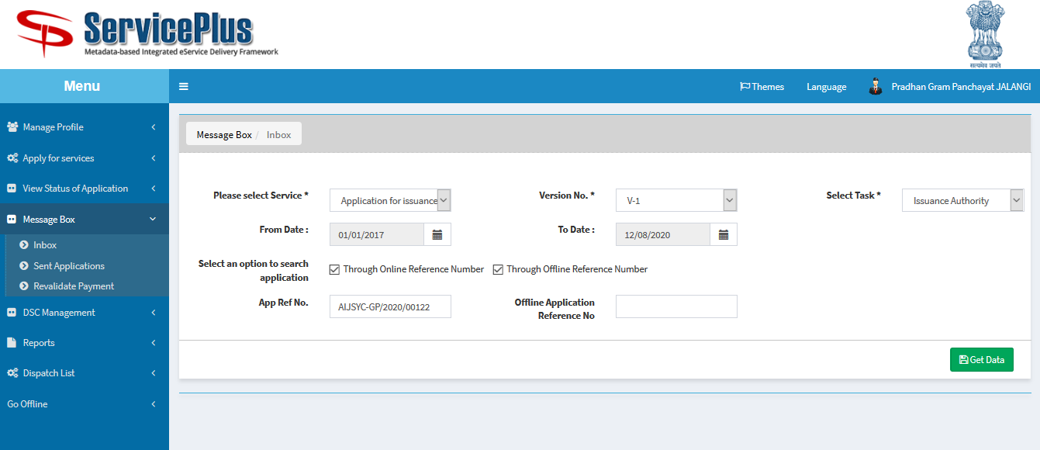

STEP 4:

Here the Pradhan has to select service “**Application for issuance of Janani Suraksha Yojana Certificate - GP**” and fetch data by hitting the button **“Get Data**” which leads to the list of pending applications.

Here “**Application Number**” can be selected to get the applicant’s detail and “**Take Action/Pull**” would lead to a new page for issuing the certificate or rejecting it.

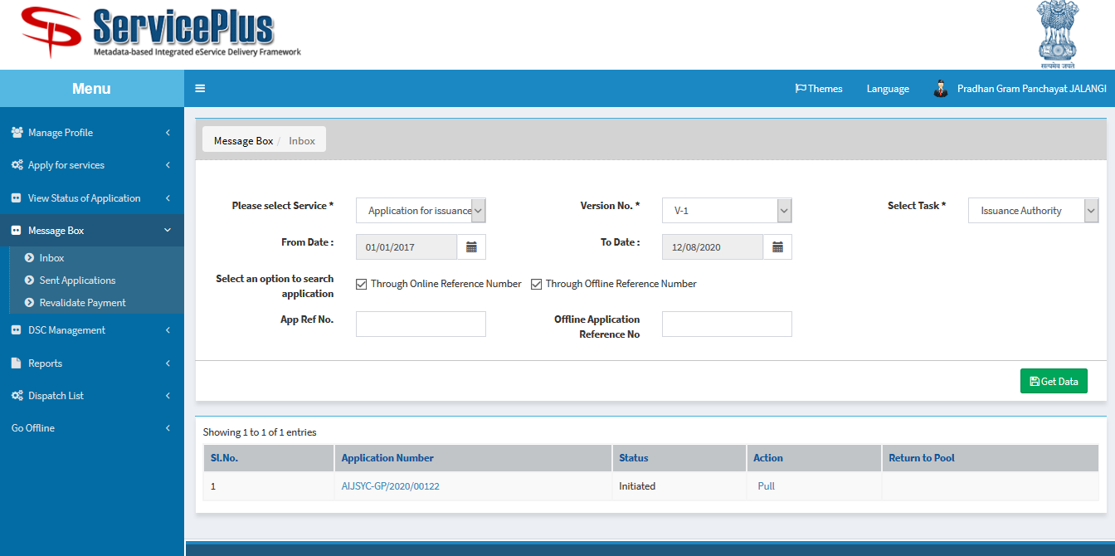

STEP 5:

By selecting ‘Action’ of ‘Reject’ or ‘Deliver’ the certificate with the respective remark can lead to form rejection or approval.

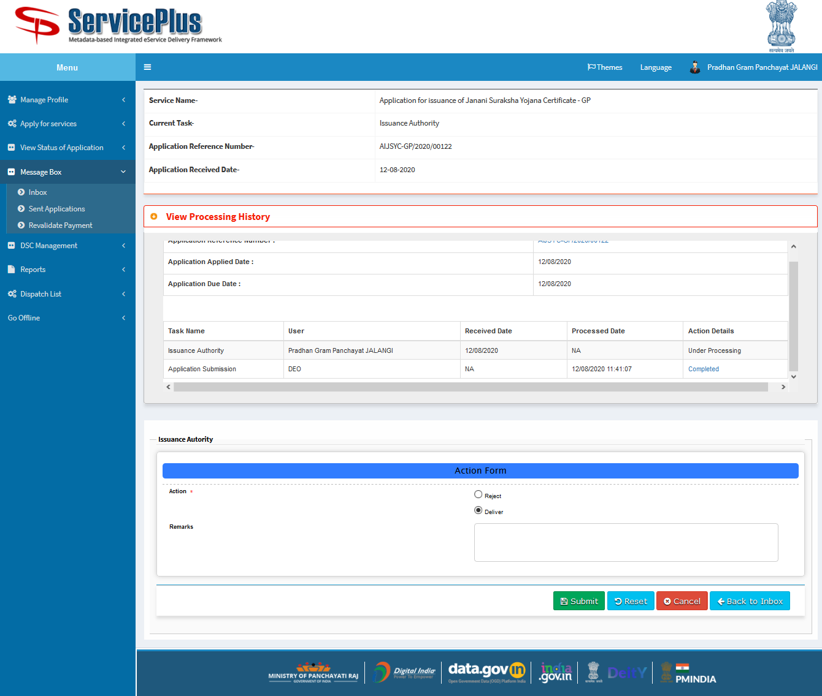

STEP 6:

Here the Pradhan has the right to see the applicant’s application form by selecting the certificate icon.

It can be further submitted or edited or viewed or cancelled.

By selecting ‘Edit Form’ button it leads to open previous page.

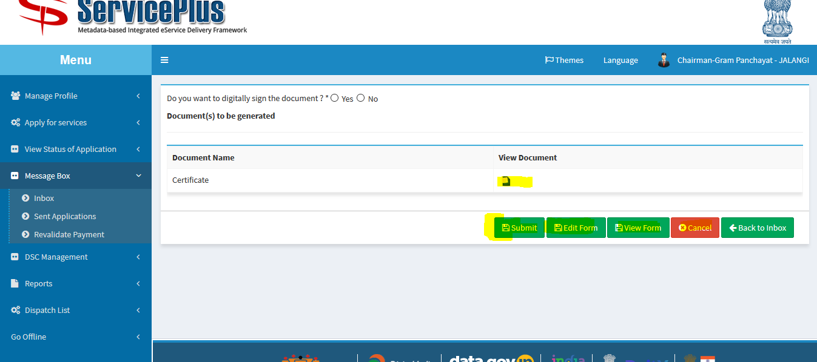

STEP 7:

By selecting “**View Processing History**” the application history can be seen such as ‘Application Applied Date’, ‘Issuance Authority’ name with date etc.

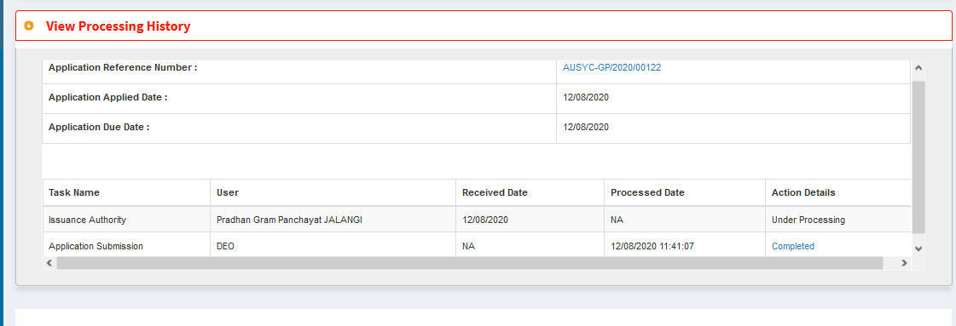

STEP 8:

By selecting view form a pop up opens which shows the state of the application.

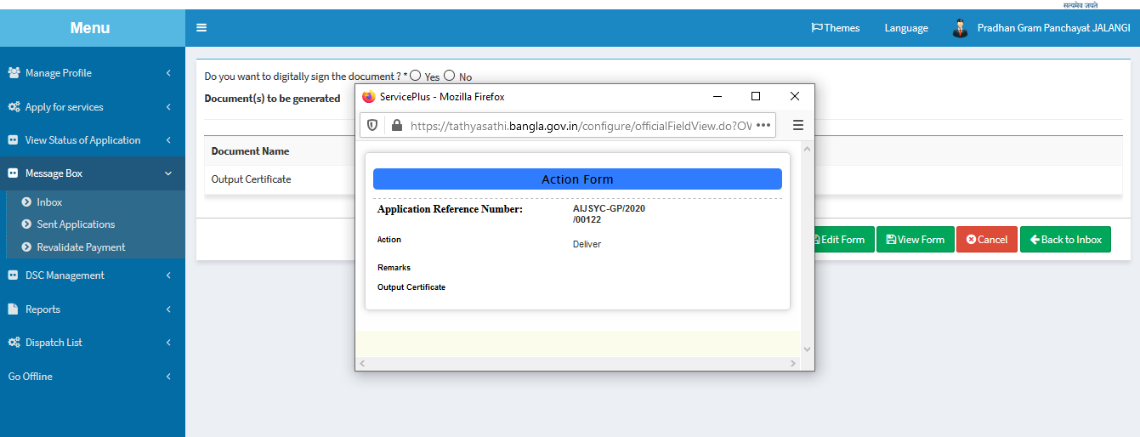

STEP 9:

After completion of all this for the final submission would be done by selecting the radio button for getting the digitally signed document or not. Then click “Submit” or other button.

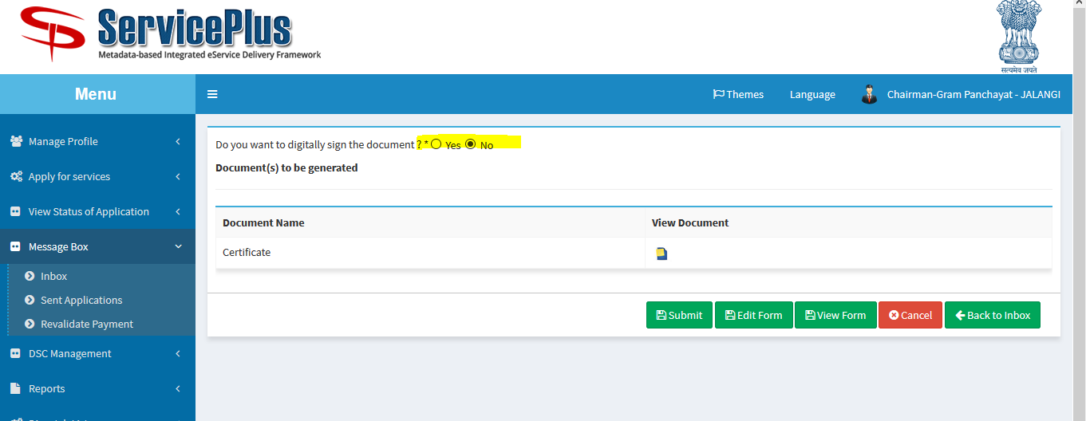

STEP 10:

Like this other application can be approved or rejected by the Pradhan authority.

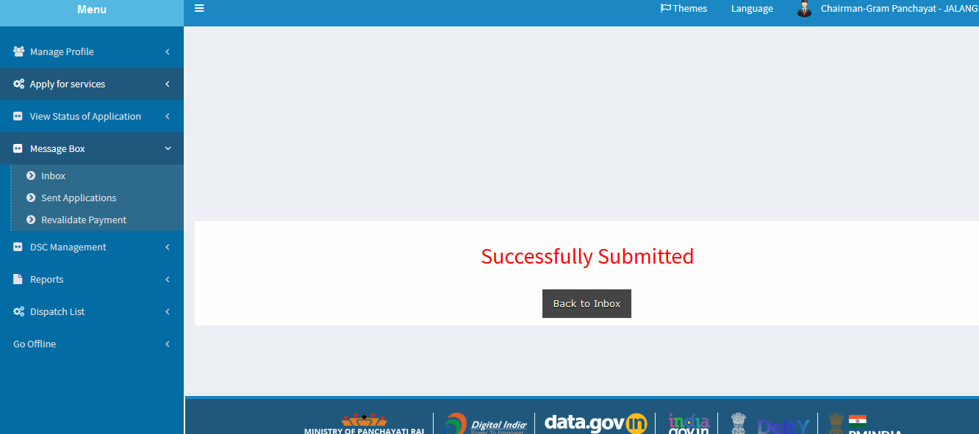

**PART IV:**

**Reporting And Certificate Dispatch: (By PRADHAN GRAM PANCHAYAT)**

**STEP 1:**

This is the dashboard showing the Total no. of application ,No. of pending Applications, Delivered Applications and Processed Application after login.

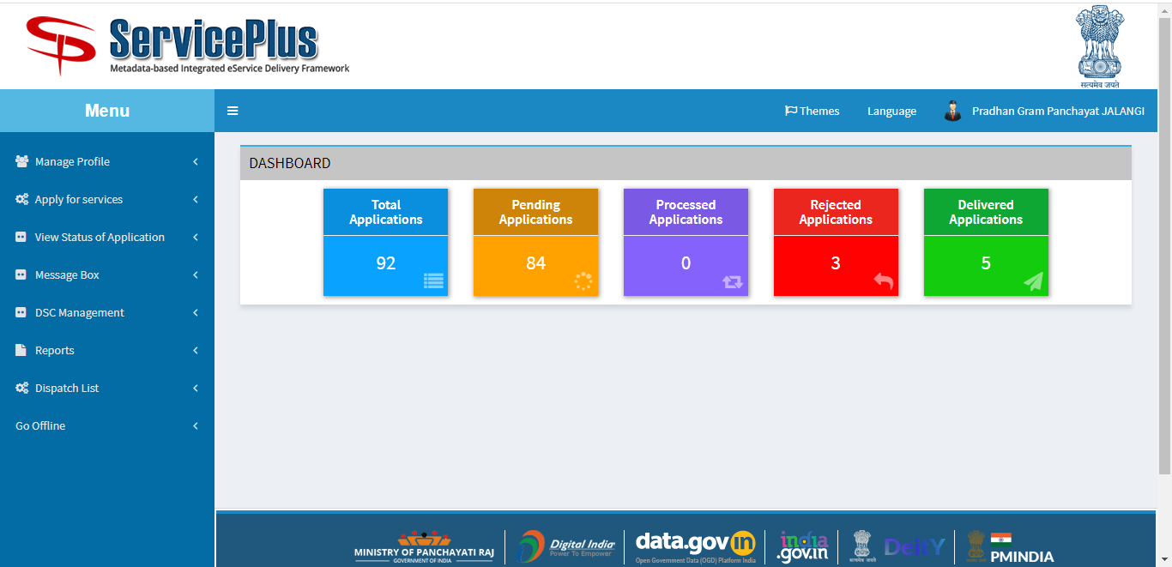

Login and goto “**Dispatch List**” and select “**View Delivered Services**” which lead to open to get the data.

We can “**select the service**” and we can also get the data in respect of date from “**From Date” – “To Date**”.

There is a option to get the data in respect of particular “**App Ref No.**” too.

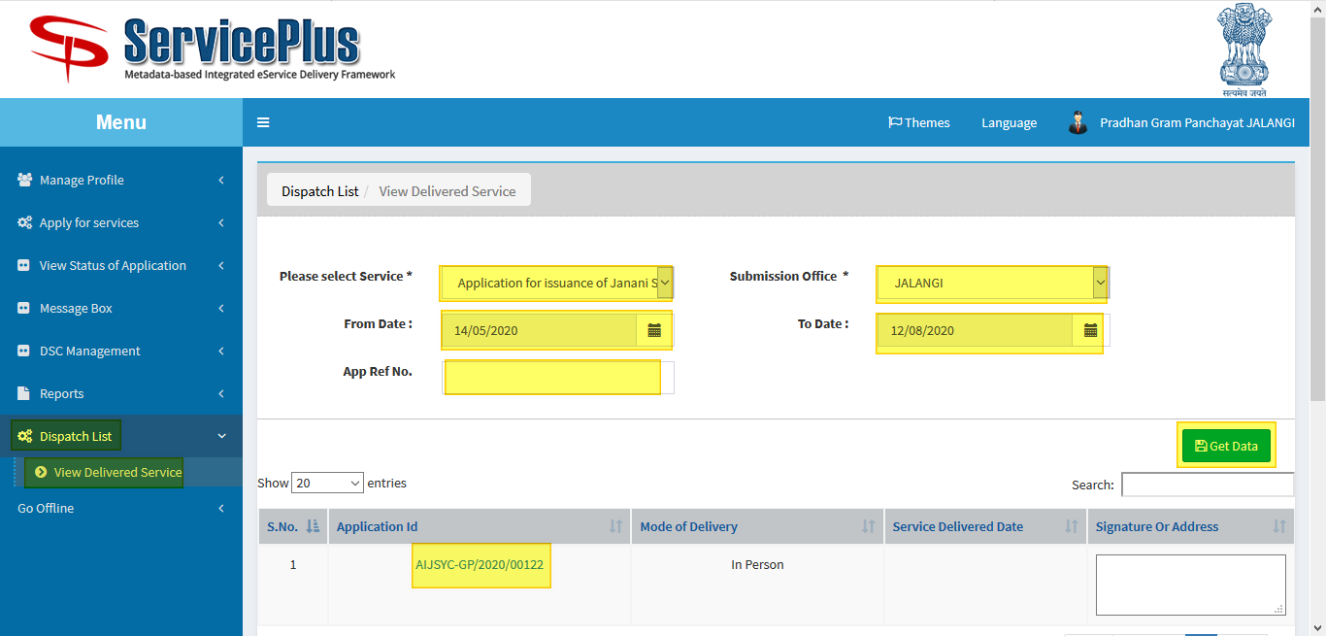

**STEP 2:**

Select the “**Application Id**” to get the dispatched certificate like below.

We can get a printout by the print button given there.

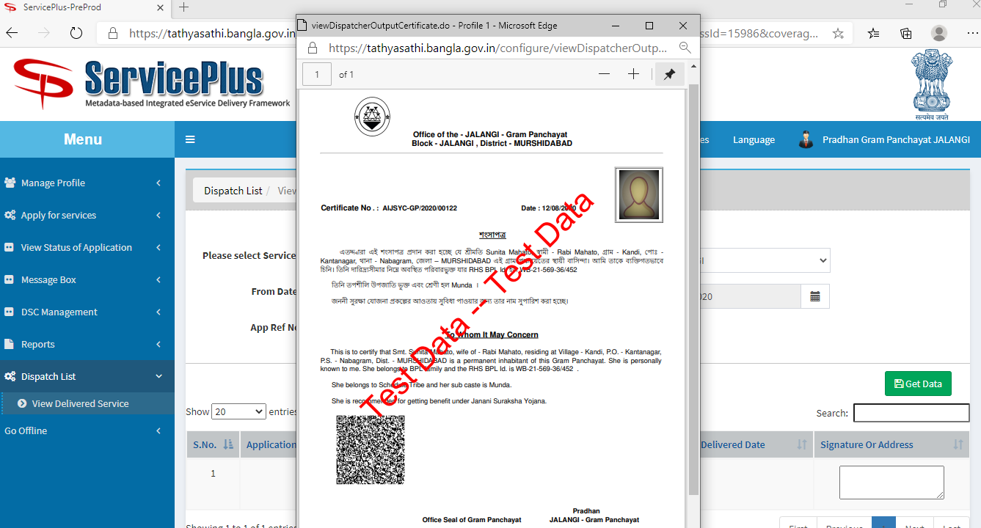

**STEP 3:**

Select to print from the list.

